**[30] Design NFA Which Should Accept String AAAAAA**

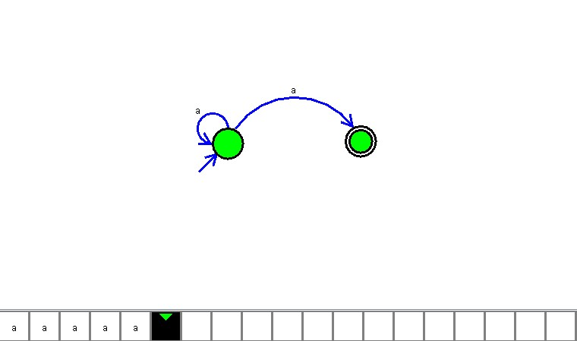

**Result**

The NFA is designed to compute the given strings as input using AutoSim tool